

**COVID CARE**

**Software Design Document**

**Table of Contents**

I. Overview 3

1. CovidCare_Final 3

II. Code Designs 4

1. Login 4

2. Register 7

3. View list Account 8

4. Ban Account 10

5. Edit Account 11

6. Create News 12

7. View Detail News 14

8. Update News 16

9. Create Post Vaccinate 17

10. Create Request Vaccinate 19

11. Appcept/ Denie Request 21

12. Recover Password 22

III. Database Design 23

1. Database Diagram: 23

2. Table Description 23

3: ERD: 24

# I. Overview

## 1. CovidCare_Final

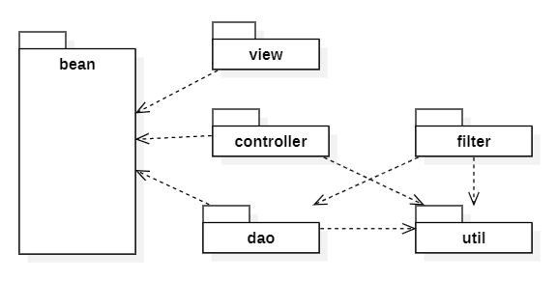

***Package descriptions & package class naming conventions***

|  |  |  |
| --- | --- | --- |
| **No** | **Package** | **Description** |
| *01* | *Controller* | *Acting as an intermediary between the Model and the View, it is responsible for receiving requests from the client, then processing the request, loading the model and sending data through the corresponding view and then returning the results to the client.* |
| *02* | *Dal* | *A pattern in which objects are reserved for communication with the Data Layer.* |
| *03* | *Model* | *Are classes that contain object information (data), interact with database access.* |
| *04* | *utils* | *The package contains the definition of some useful classes that provide a lot of functionality. The package mainly contains collection classes useful for working with groups of objects. This package also contains definitions of classes that provide date and time utilities and many more* |
| *05* | *view* | *Is the place to receive data from the model, database and arrange them correctly thanks to the request from the controller and transmit it to the client.* |

# II. Code Designs

## 1. Login

**a. Class Diagram:**

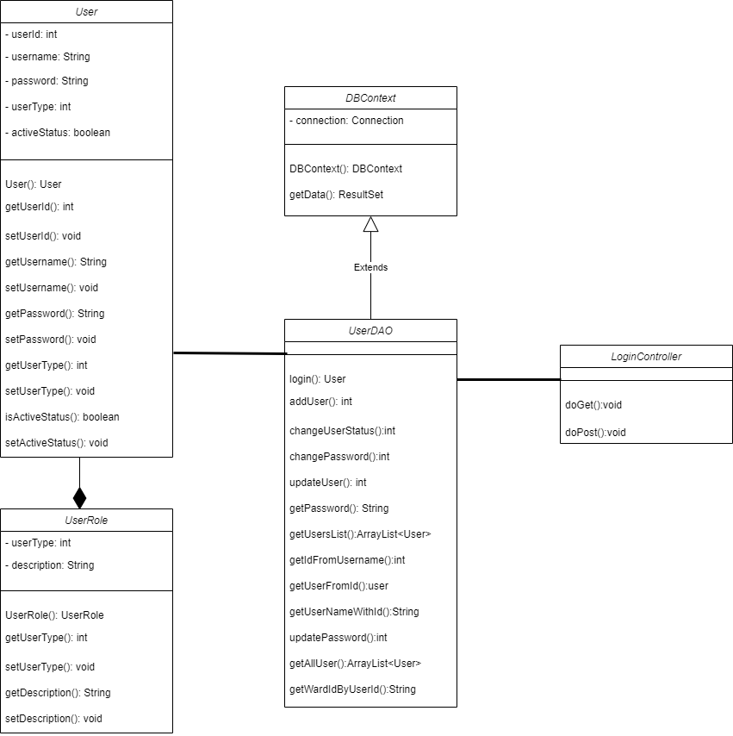

*Login_Class Diagram*

1. **Class Specification**

|  |  |  |
| --- | --- | --- |
| **No** | **Method** | **Description** |
| 01 | User() | Contructor of object User. |
| 02 | getUserId() | Return value of attribute userId |
| 03 | setUserId() | Set value to attribute userId |
| 04 | getUsername() | Return value of attribute userId |
| 05 | setUsername() | Set value to attribute userId |
| 06 | getPassword() | Return attribute password |
| 07 | setPassword() | Set value to attribute password |
| 08 | getUserType() | Return value of attribute userType |
| 09 | setUserType () | Set value to attribute userType |
| 10 | isActiveStatus() | Return value of attribute activeStatus |
| 11 | setActiveStatus() | Set value to attribute activeStatus |
| 12 | Login(User user) | Get data from database then create and return User object |
| 13 | addUser(User user) | Add data object User to database |
| 14 | ChangeUserStatus(userId, activeFlag) | Update data column *activeStatus* of table Users |
| 15 | changePassword(user) | Update data column *password* of table Users |
| 16 | updateUser(user) | Update data all column of table Users |
| 17 | getUsersList() | Get all data from table User, create object User then return list User. |
| 18 | getIdFromUsername(username) | Return Id of username input. |
| 19 | getUserFromId(Id) | Return User have Id same with input Id. |
| 20 | getUserNameWithId(Id) | Return username at object User have id same with input Id |
| 21 | getWardIdByUserId(userId) | Return ward id belong to user. |

1. **Sequense Diagram**

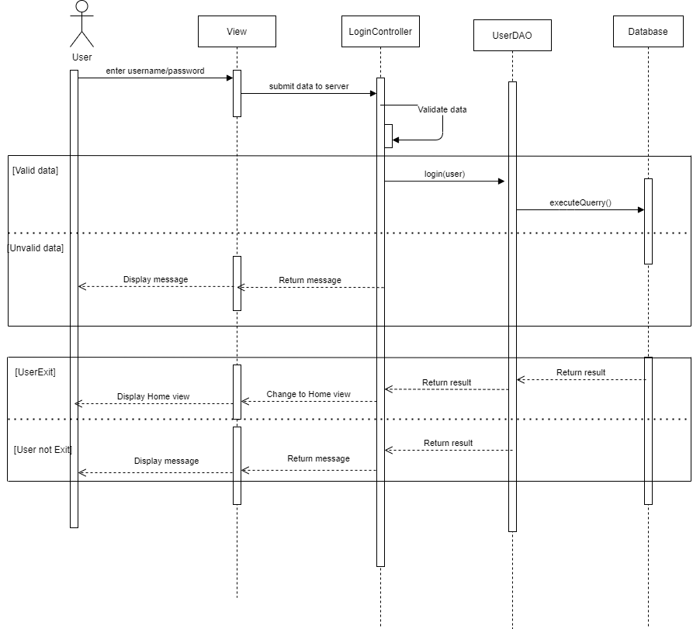

*Login_Sequense Diagram*

## 2. Register

**a. Class Diagram:**

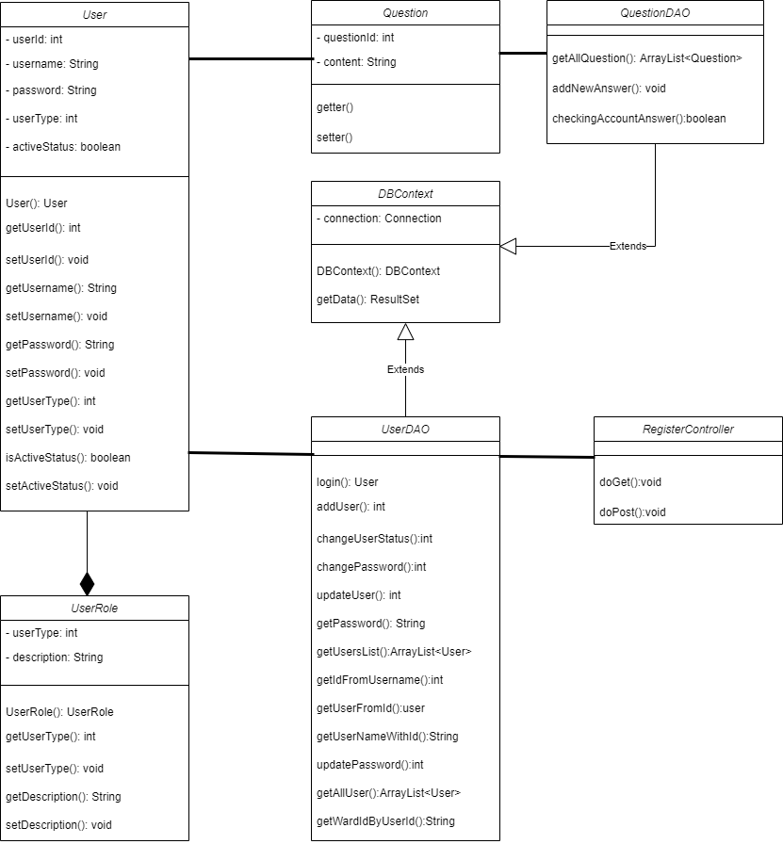

*Register_Class Diagram*

1. **Class Specification**

|  |  |  |
| --- | --- | --- |
| **No** | **Method** | **Description** |
| 01 | addUser(user) | Add new User information to Database |
| 02 | getAllQuestion() | Get all question |

1. **Sequense Diagram**

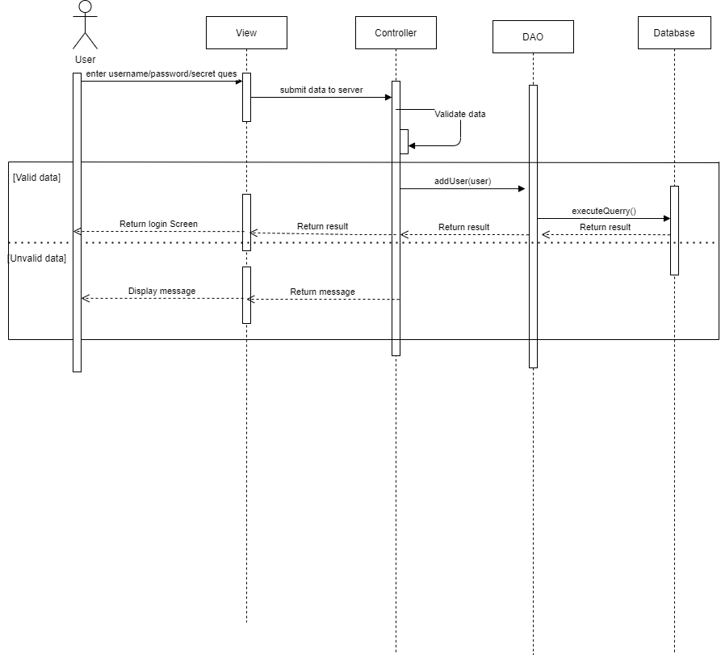

*Register_Sequense Diagram*

## 3. View list Account

**a. Class Diagram:**

*View list Account_Class Diagram*

1. **Class Specification**

|  |  |  |
| --- | --- | --- |
| **No** | **Method** | **Description** |
| 01 | User() | Contructor of object User. |
| 02 | getUserId() | Return value of attribute userId |
| 03 | setUserId() | Set value to attribute userId |
| 04 | getUsername() | Return value of attribute userId |
| 05 | setUsername() | Set value to attribute userId |
| 06 | getPassword() | Return attribute password |
| 07 | setPassword() | Set value to attribute password |
| 08 | getUserType() | Return value of attribute userType |
| 09 | setUserType () | Set value to attribute userType |
| 10 | isActiveStatus() | Return value of attribute activeStatus |
| 11 | setActiveStatus() | Set value to attribute activeStatus |
| 12 | Login(User user) | Get data from database then create and return User object |
| 13 | addUser(User user) | Add data object User to database |
| 14 | ChangeUserStatus(userId, activeFlag) | Update data column *activeStatus* of table Users |
| 15 | changePassword(user) | Update data column *password* of table Users |
| 16 | updateUser(user) | Update data all column of table Users |
| 17 | getUsersList() | Get all data from table User, create object User then return list User. |
| 18 | getIdFromUsername(username) | Return Id of username input. |
| 19 | getUserFromId(Id) | Return User have Id same with input Id. |
| 20 | getUserNameWithId(Id) | Return username at object User have id same with input Id |
| 21 | getWardIdByUserId(userId) | Return ward id belong to user. |

1. **Sequense Diagram**

*View list Account _Sequense Diagram*

## 4. Ban Account

**a. Class Diagram:**

*Ban Account_Class Diagram*

1. **Class Specification**

|  |  |  |
| --- | --- | --- |
| **No** | **Method** | **Description** |
| 01 | User() | Contructor of object User. |
| 02 | getUserId() | Return value of attribute userId |
| 03 | setUserId() | Set value to attribute userId |
| 04 | getUsername() | Return value of attribute userId |
| 05 | setUsername() | Set value to attribute userId |
| 06 | getPassword() | Return attribute password |
| 07 | setPassword() | Set value to attribute password |
| 08 | getUserType() | Return value of attribute userType |
| 09 | setUserType () | Set value to attribute userType |
| 10 | isActiveStatus() | Return value of attribute activeStatus |
| 11 | setActiveStatus() | Set value to attribute activeStatus |
| 12 | Login(User user) | Get data from database then create and return User object |
| 13 | addUser(User user) | Add data object User to database |
| 14 | ChangeUserStatus(userId, activeFlag) | Update data column *activeStatus* of table Users |
| 15 | changePassword(user) | Update data column *password* of table Users |
| 16 | updateUser(user) | Update data all column of table Users |
| 17 | getUsersList() | Get all data from table User, create object User then return list User. |
| 18 | getIdFromUsername(username) | Return Id of username input. |
| 19 | getUserFromId(Id) | Return User have Id same with input Id. |
| 20 | getUserNameWithId(Id) | Return username at object User have id same with input Id |
| 21 | getWardIdByUserId(userId) | Return ward id belong to user. |

1. **Sequense Diagram**

*Ban Account _Sequense Diagram*

## 5. Edit Account

**a. Class Diagram:**

*Edit Account_Class Diagram*

1. **Class Specification**

|  |  |  |
| --- | --- | --- |
| **No** | **Method** | **Description** |
| 01 | User() | Contructor of object User. |
| 02 | getUserId() | Return value of attribute userId |
| 03 | setUserId() | Set value to attribute userId |
| 04 | getUsername() | Return value of attribute userId |
| 05 | setUsername() | Set value to attribute userId |
| 06 | getPassword() | Return attribute password |
| 07 | setPassword() | Set value to attribute password |
| 08 | getUserType() | Return value of attribute userType |
| 09 | setUserType () | Set value to attribute userType |
| 10 | isActiveStatus() | Return value of attribute activeStatus |
| 11 | setActiveStatus() | Set value to attribute activeStatus |
| 12 | Login(User user) | Get data from database then create and return User object |
| 13 | addUser(User user) | Add data object User to database |
| 14 | ChangeUserStatus(userId, activeFlag) | Update data column *activeStatus* of table Users |
| 15 | changePassword(user) | Update data column *password* of table Users |
| 16 | updateUser(user) | Update data all column of table Users |
| 17 | getUsersList() | Get all data from table User, create object User then return list User. |
| 18 | getIdFromUsername(username) | Return Id of username input. |
| 19 | getUserFromId(Id) | Return User have Id same with input Id. |
| 20 | getUserNameWithId(Id) | Return username at object User have id same with input Id |
| 21 | getWardIdByUserId(userId) | Return ward id belong to user. |

1. **Sequense Diagram**

*Edit Account_Sequense Diagram*

## 6. Create News

**a. Class Diagram:**

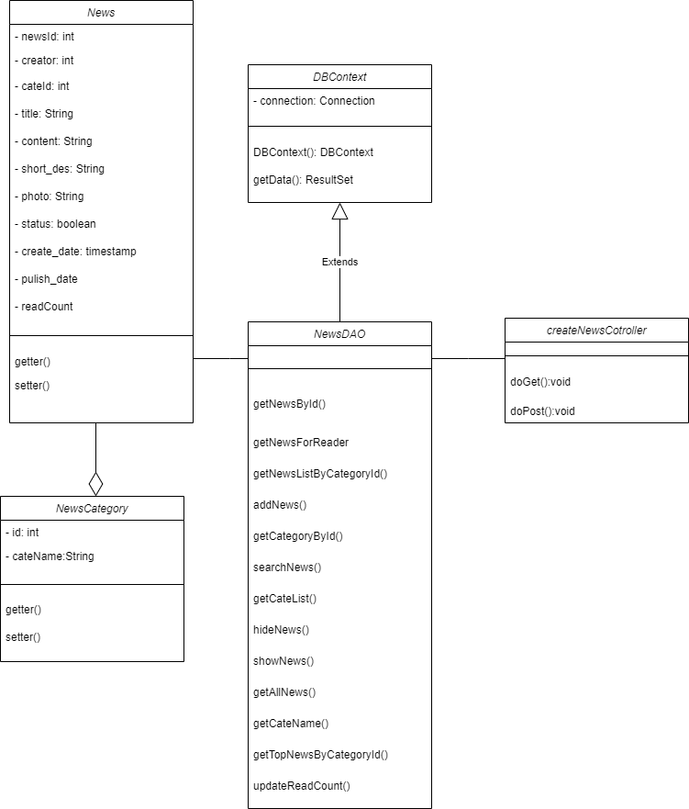

*Create News_Class Diagram*

1. **Class Specification**

|  |  |  |
| --- | --- | --- |
| **No** | **Method** | **Description** |
| 01 | getNewsById() | Get News by News id |
| 02 | getNewsForReader() | Get News with news status equad to 1 |
| 03 | getNewsListByCategoryId() | Get News with cate id |
| 04 | addNews() | Insert new News |
| 05 | updateNews() | Update News |
| 06 | getCategoryById() | Get name of category by category id |
| 07 | searchNews() | Search News contain input text |
| 08 | getCateList() | Get list category |
| 09 | hideNews() | Update status News equad to 0 |
| 10 | showNews() | Update status News equad to 1 |
| 11 | getAllNews() | Get all news |
| 12 | getCateName() | Get category name |
| 13 | getTopNewsByCategoryId() | Get top 4 news with closest publish date |
| 14 | updateReadCount | Update time of read |

1. **Sequense Diagram**

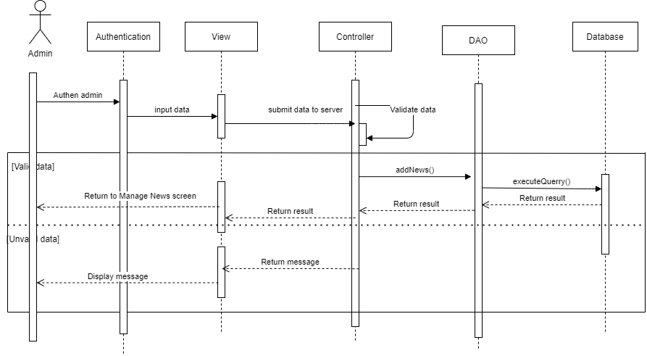

*Create News _Sequense Diagram*

## 7. View Detail News

**a. Class Diagram:**

*View Detail News_Class Diagram*

1. **Class Specification**

|  |  |  |
| --- | --- | --- |
| **No** | **Method** | **Description** |
| 01 | User() | Contructor of object User. |
| 02 | getUserId() | Return value of attribute userId |
| 03 | setUserId() | Set value to attribute userId |
| 04 | getUsername() | Return value of attribute userId |
| 05 | setUsername() | Set value to attribute userId |
| 06 | getPassword() | Return attribute password |
| 07 | setPassword() | Set value to attribute password |
| 08 | getUserType() | Return value of attribute userType |
| 09 | setUserType () | Set value to attribute userType |
| 10 | isActiveStatus() | Return value of attribute activeStatus |
| 11 | setActiveStatus() | Set value to attribute activeStatus |
| 12 | Login(User user) | Get data from database then create and return User object |
| 13 | addUser(User user) | Add data object User to database |
| 14 | ChangeUserStatus(userId, activeFlag) | Update data column *activeStatus* of table Users |
| 15 | changePassword(user) | Update data column *password* of table Users |
| 16 | updateUser(user) | Update data all column of table Users |
| 17 | getUsersList() | Get all data from table User, create object User then return list User. |
| 18 | getIdFromUsername(username) | Return Id of username input. |
| 19 | getUserFromId(Id) | Return User have Id same with input Id. |
| 20 | getUserNameWithId(Id) | Return username at object User have id same with input Id |
| 21 | getWardIdByUserId(userId) | Return ward id belong to user. |

1. **Sequense Diagram**

*View Detail News _Sequense Diagram*

## 8. Update News

**a. Class Diagram:**

*Update News_Class Diagram*

1. **Class Specification**

|  |  |  |
| --- | --- | --- |
| **No** | **Method** | **Description** |
| 01 | User() | Contructor of object User. |
| 02 | getUserId() | Return value of attribute userId |
| 03 | setUserId() | Set value to attribute userId |
| 04 | getUsername() | Return value of attribute userId |
| 05 | setUsername() | Set value to attribute userId |
| 06 | getPassword() | Return attribute password |
| 07 | setPassword() | Set value to attribute password |
| 08 | getUserType() | Return value of attribute userType |
| 09 | setUserType () | Set value to attribute userType |
| 10 | isActiveStatus() | Return value of attribute activeStatus |
| 11 | setActiveStatus() | Set value to attribute activeStatus |
| 12 | Login(User user) | Get data from database then create and return User object |
| 13 | addUser(User user) | Add data object User to database |
| 14 | ChangeUserStatus(userId, activeFlag) | Update data column *activeStatus* of table Users |
| 15 | changePassword(user) | Update data column *password* of table Users |
| 16 | updateUser(user) | Update data all column of table Users |
| 17 | getUsersList() | Get all data from table User, create object User then return list User. |
| 18 | getIdFromUsername(username) | Return Id of username input. |
| 19 | getUserFromId(Id) | Return User have Id same with input Id. |
| 20 | getUserNameWithId(Id) | Return username at object User have id same with input Id |
| 21 | getWardIdByUserId(userId) | Return ward id belong to user. |

1. **Sequense Diagram**

*Update News _Sequense Diagram*

## 9. Create Post Vaccinate

**a. Class Diagram:** 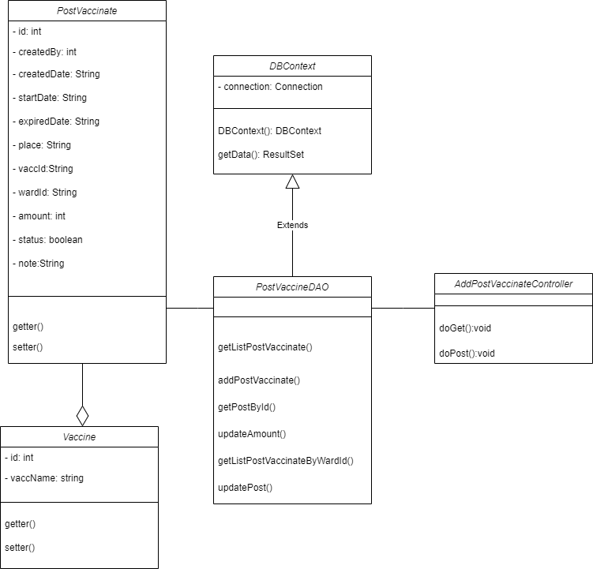

*Create Post Vaccinate_Class Diagram*

1. **Class Specification**

|  |  |  |
| --- | --- | --- |
| **No** | **Method** | **Description** |
| 01 | getListPostVacinate() | Get all Post in Database |
| 02 | addPostVaccinate() | Add new Post into database |
| 03 | getPostById() | Get Post by id of post |
| 04 | updateAmount() | Update amount number vaccin. |
| 05 | getListPostVaccinateByWarId() | Get list post with wardId |
| 06 | updatePost() | Update all attributes of Post |

1. **Sequense Diagram**

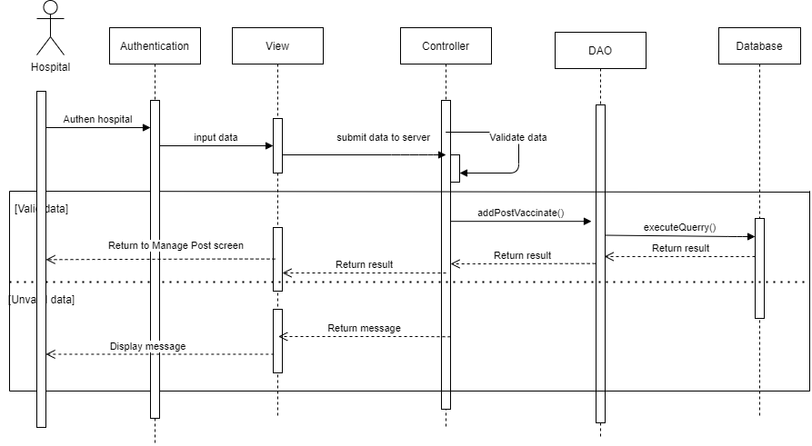

*Create Post Vaccinate _Sequense Diagram*

## 10. Create Request Vaccinate

**a. Class Diagram:**

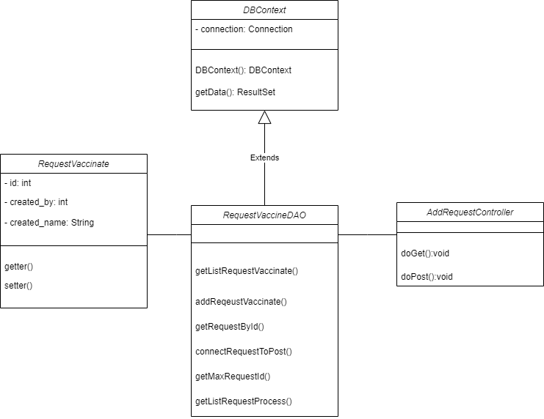

*Create Request Vaccinate_Class Diagram*

1. **Class Specification**

|  |  |  |
| --- | --- | --- |
| **No** | **Method** | **Description** |
| 01 | getListRequestVaccinate() | Get list request vaccinate of user |
| 02 | addRequestById() | Add new request. |
| 03 | connectRequestToPost() | Add request to Post |
| 04 | getMaxRequestId() | Get closest request id |
| 05 | getListRequestProcess() | Get list request with status equal to 2 |

1. **Sequense Diagram**

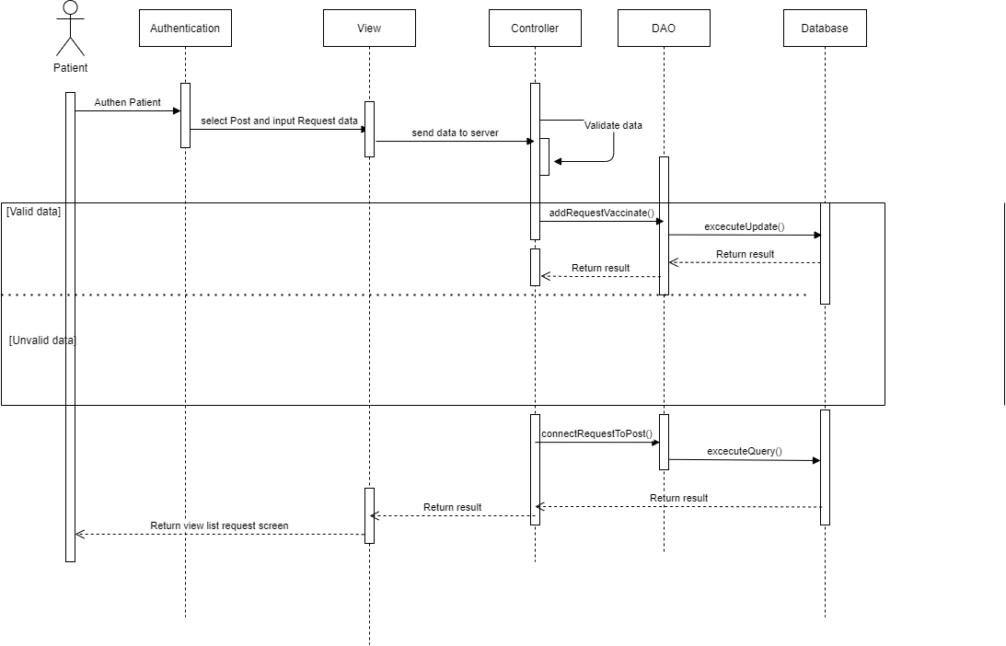

*Create Request Vaccinate _Sequense Diagram*

## 11. Appcept/ Denie Request

**a. Class Diagram:** 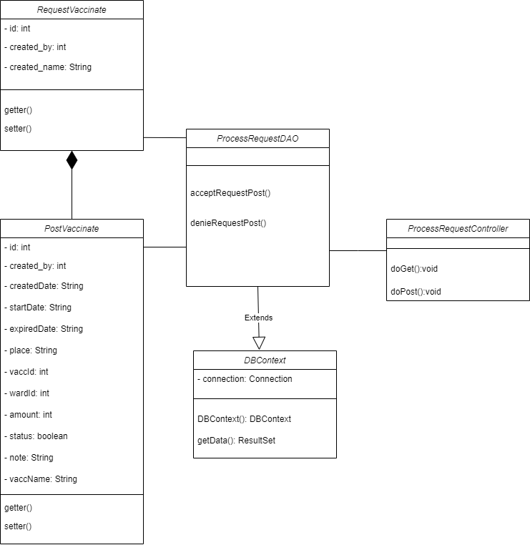

*Accept Request_Class Diagram*

1. **Class Specification**

|  |  |  |
| --- | --- | --- |
| **No** | **Method** | **Description** |
| 01 | acceptRequestPost() | Set status request of post is 1 |
| 02 | denieRequestPost() | Set status request of post is 0 |

1. **Sequense Diagram**

*Accept Request _Sequense Diagram*

## 12. Recover Password

**a. Class Diagram:**

*Recover Password_Class Diagram*

1. **Class Specification**

|  |  |  |
| --- | --- | --- |
| **No** | **Method** | **Description** |
| 01 | User() | Contructor of object User. |
| 02 | getUserId() | Return value of attribute userId |
| 03 | setUserId() | Set value to attribute userId |
| 04 | getUsername() | Return value of attribute userId |
| 05 | setUsername() | Set value to attribute userId |
| 06 | getPassword() | Return attribute password |
| 07 | setPassword() | Set value to attribute password |
| 08 | getUserType() | Return value of attribute userType |
| 09 | setUserType () | Set value to attribute userType |
| 10 | isActiveStatus() | Return value of attribute activeStatus |
| 11 | setActiveStatus() | Set value to attribute activeStatus |
| 12 | Login(User user) | Get data from database then create and return User object |
| 13 | addUser(User user) | Add data object User to database |
| 14 | ChangeUserStatus(userId, activeFlag) | Update data column *activeStatus* of table Users |
| 15 | changePassword(user) | Update data column *password* of table Users |
| 16 | updateUser(user) | Update data all column of table Users |
| 17 | getUsersList() | Get all data from table User, create object User then return list User. |
| 18 | getIdFromUsername(username) | Return Id of username input. |
| 19 | getUserFromId(Id) | Return User have Id same with input Id. |
| 20 | getUserNameWithId(Id) | Return username at object User have id same with input Id |
| 21 | getWardIdByUserId(userId) | Return ward id belong to user. |

1. **Sequense Diagram**

*Recover Password _Sequense Diagram*

# III. Database Design

## Database Diagram:

1. Image:
2. 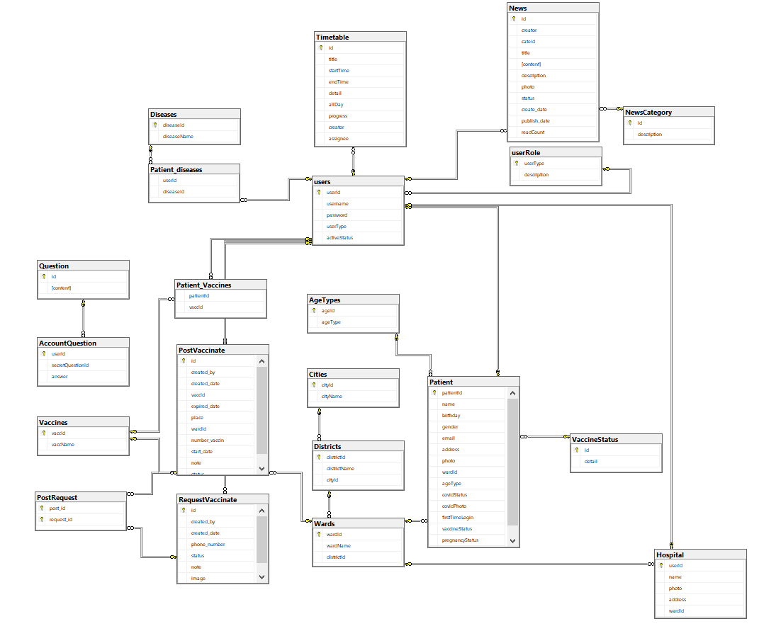*Img:Database Diagram.*

## 2. Table Description

|  |  |  |
| --- | --- | --- |
| **No** | **Table** | **Description** |
| *01* | *<Table name>* | *<Description of the table>*  *- Primary keys: <<list of primary key fields>>*  *- Foreign keys: <<list of foreign key fields>>* |
| *02* |  |  |

## 3: ERD:

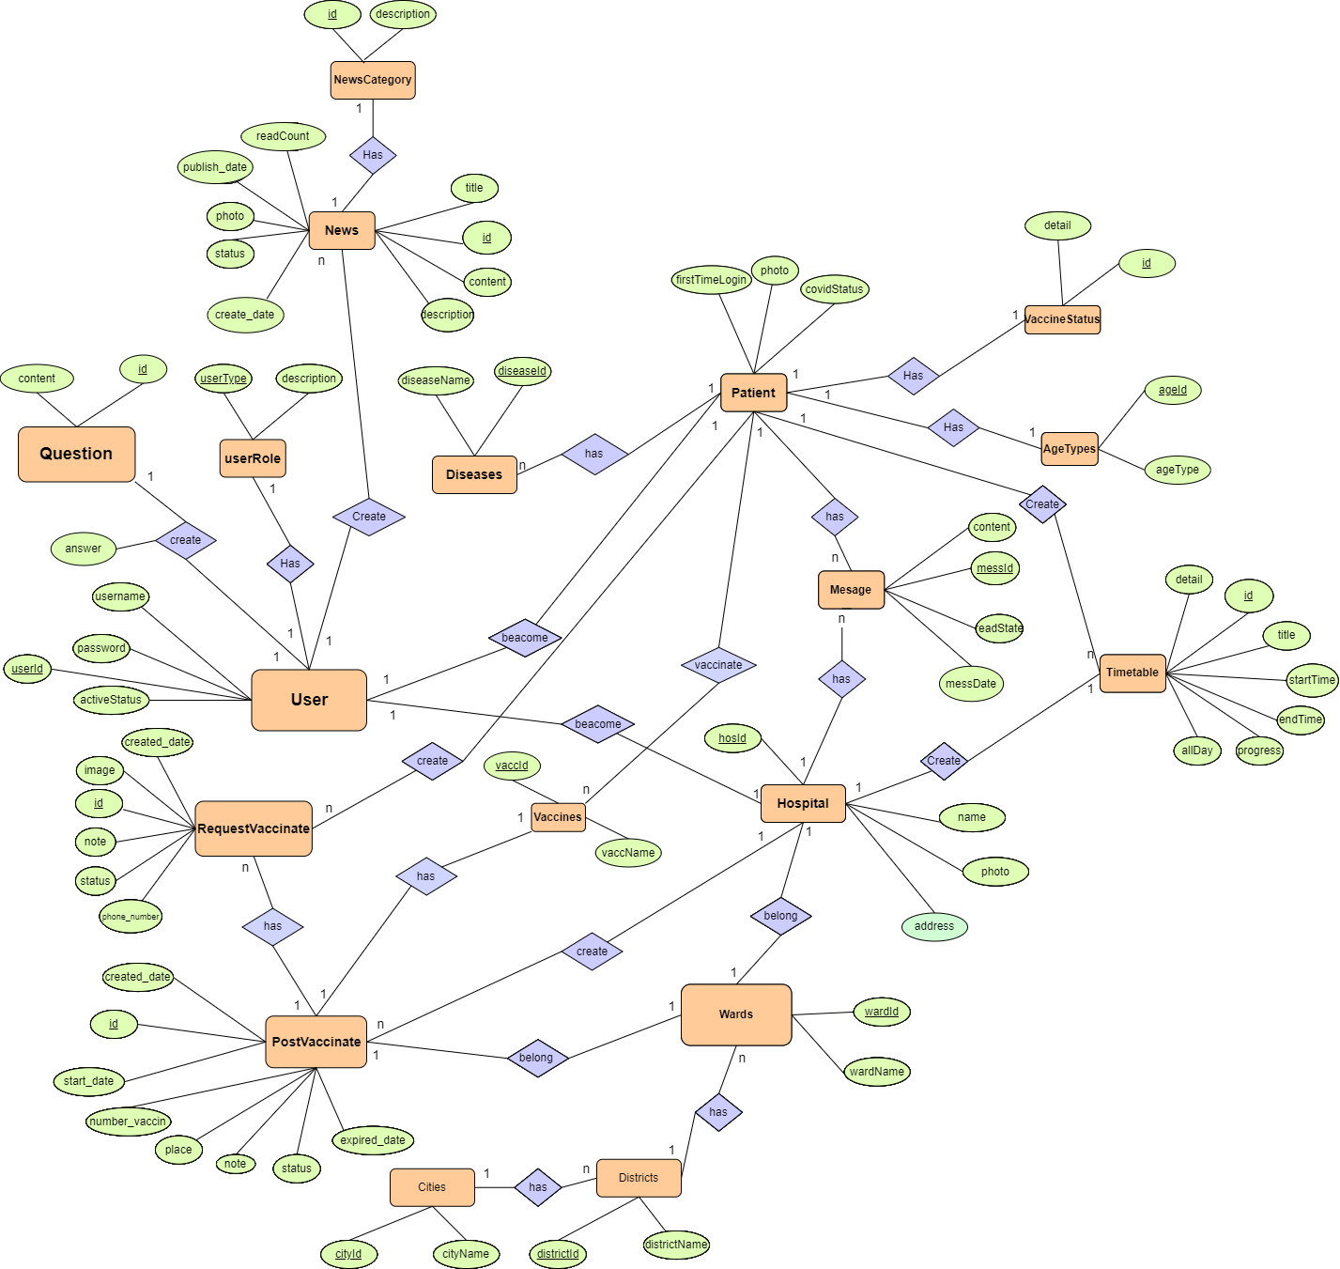

*Img:Database Diagram.*